

PROJECT AND TEAM INFORMATION

Project Title

HOSPITAL MANAGEMENT SYSTEM USING MERN

Student/Team Information

Team Name:  Team id: | Opticruze  FS-T190
Team member 1 (Team Lead) | Lingwal,Ishank -230211112  ishanklingwal993@gmail.com  
Team member 2 | Tomar, Ayushi -230223592  ayushitomar624@gmail.com  
Team member 3 | Baliyan,Yashika-23022496  yashikabaliyan57@gmail.com  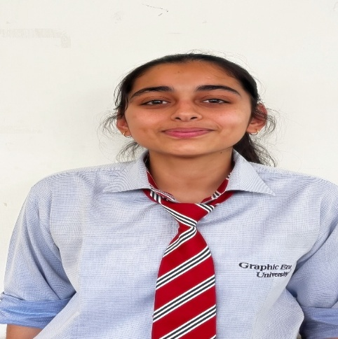
Team member 4 | Tomar,Prashant-230211589  prashanttomar1645@gmail.com  

PROJECT PROGRESS DESCRIPTION (35 pts)

Project Abstract (2 pts)
The project developed is a web-based application built on a technology stack known as MERN, which consists of MongoDB, Express, React, and Node. This project aims to provide a solution for managing hospital-related activities such as patient management, doctor management, appointment management, etc.

The main idea behind creating this project is to automate the hospital management system, which helps in reducing errors. This project provides a variety of features such as user management, doctor management, etc. This project helps in handling data securely

Updated Project Approach and Architecture (2 pts)
- It was developed iteratively, adding features one by one and testing continuously.
- It uses MERN stack architecture, which consists of MongoDB, Express.js, React.js, and Node.js.
- It consists of three layers: front end, back end, and database.
- React.js front end takes care of user interface and API requests.
- Node.js/Express back end takes care of business logic and API requests.
- MongoDB database takes care of user, doctor, and appointment data.

Tasks Completed (7 pts)
Task Completed | Team Member
- Designed System Architecture
- Implemented MERN Stack
- Implemented Frontend Interface using react.js
- Implemented Backend APIs using node.js and express.js
- Implemented Database Connection
- Implemented Basic Schemas
- Implemented User Authentication System(login/registration)
- Implemented Core Modules
- Integrated Frontend and Backend APIs
- Performed Basic Testing

Challenges/Roadblocks (5 pts)
1.Difficulty was faced in integrating the front end (React) with backend APIs, particularly in handling asynchronous data.
2.It was challenging to handle MongoDB schema design along with relationships between users, doctors, and appointments.
3.It was challenging to implement authentication/authorization securely by handling tokens/sessions appropriately.
4.Faced bugs/errors during API development, which was time-consuming to debug and fix.
5.It was challenging to ensure smooth UI responsiveness.

Tasks Pending (7 pts)
Task Pending | Team Member (to complete the task)
1.Implementation of sophisticated features in the admin dashboard.
2.Improvement in UI/UX design.
3.Implementation of other features such as a notification system or payment system.
4.Improvement in the security features.
5.Execution of complete testing (unit testing and integration testing).
6.Fixing of bugs in the system.
7.Deploying the application on a live server or cloud environment

Project Outcome/Deliverables
1.A fully functional Hospital Management System web application developed using the MERN stack.
2.User, Doctor, and Admin modules with role-based functionality.
3.RESTful APIs for data communication between frontend and backend.
4.A structured MongoDB database with separate collections for Users, Doctors, and Appointments.
5.User authentication system with login and registration functionality.
6.Basic UI interface for booking appointments.
7.Project documentation and report explaining the system's design and implementation.

Progress Overview
1.Completed design and planning of the "Hospital Management System."
2.Created a basic frontend interface using "React.js."
3.Created backend APIs using "Node.js" and "Express.js."
4.Set up a MongoDB database and created schemas.
5.Integrated frontend with backend for core functionality.
6.Implemented user authentication and appointment functionality.
7.Completed initial testing and debugging to get a working prototype

Codebase Information
1.The project is based on modular code, with separate folders for the frontend and backend.
2.The frontend, based on React.js, includes components, pages, and services.
3.The backend, based on Node.js and Express.js, includes routes, controllers, and middleware.
4.MongoDB schemas/models are used to define the structure of users, doctors, and appointments.
5.RESTful APIs are implemented to enable communication between the frontend and backend.
6.Git/GitHub is used to maintain version control.
7.The code is written to be scalable and maintainable.

Testing and Validation Status
Test Type | Status (Pass/Fail) | Notes
Notes  1.Unit Testing Core modules like login and booking working  2.Integration Testing Frontend and backend properly connected  3.API Testing (Postman) All endpoints returning correct responses  4.Authentication Testing Login/Signup functioning correctly  5.Data Validation Testing Input fields properly validated  6.UI Testing Interface responsive and user-friendly  7.Bug Testing | Pass  Pass  Pass  Pass  Pass  Pass  Pass | Core modules like login and booking working  Frontend and backend properly connected  All endpoints are returning proper responses  Login/Signup is working correctly  Input fields are being properly validated  Input fields are being properly validated  Input fields are being properly validated

Deliverables Progress
1Completed project design and system architecture planning.
2.Designed the frontend interface using React.js.
3.Completed backend API development using Node.js and Express.js.
4.Configured the database using MongoDB with necessary schema and collections.
5.Completed user authentication feature development (login and registration).
6.Designed core features like appointment booking and doctor management.
7.Completed initial testing and debugging of the system.
8.Deployment and advanced features development are pending for Phase 3.

